**Control System Laboratory Report**

**Name and ID no. of the Student: Raghuram C S 2019A3PS0357H**

**BALANCE CONTROL**

**MATLAB Simulink model and balance control in simulation environment**

**Model/Simulation:**

PD Controller based balance control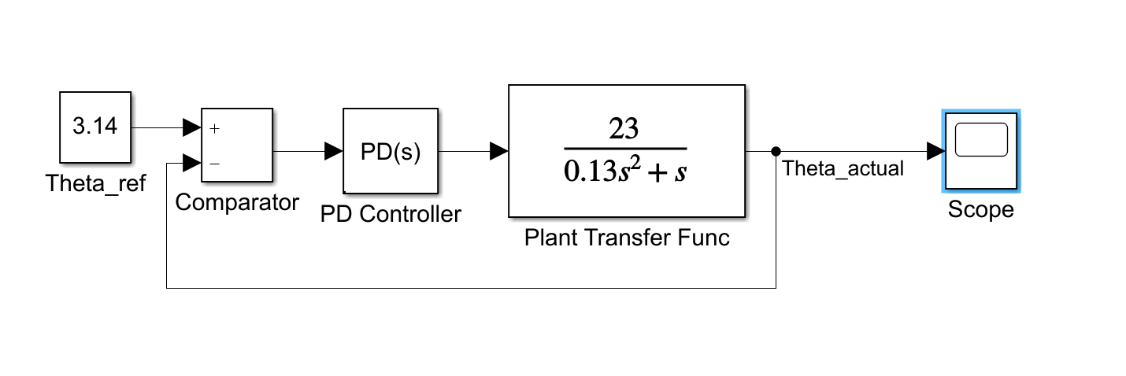

**Results:**

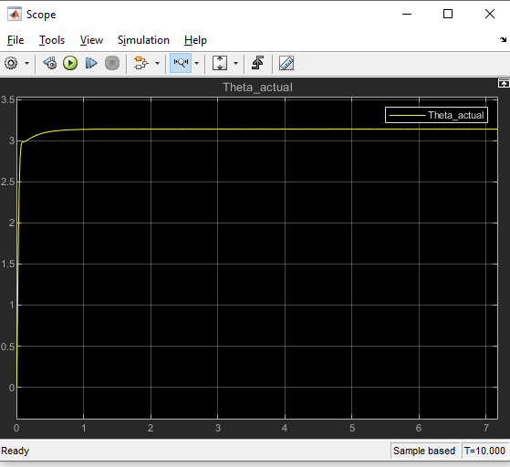

Zoomed in Scope View

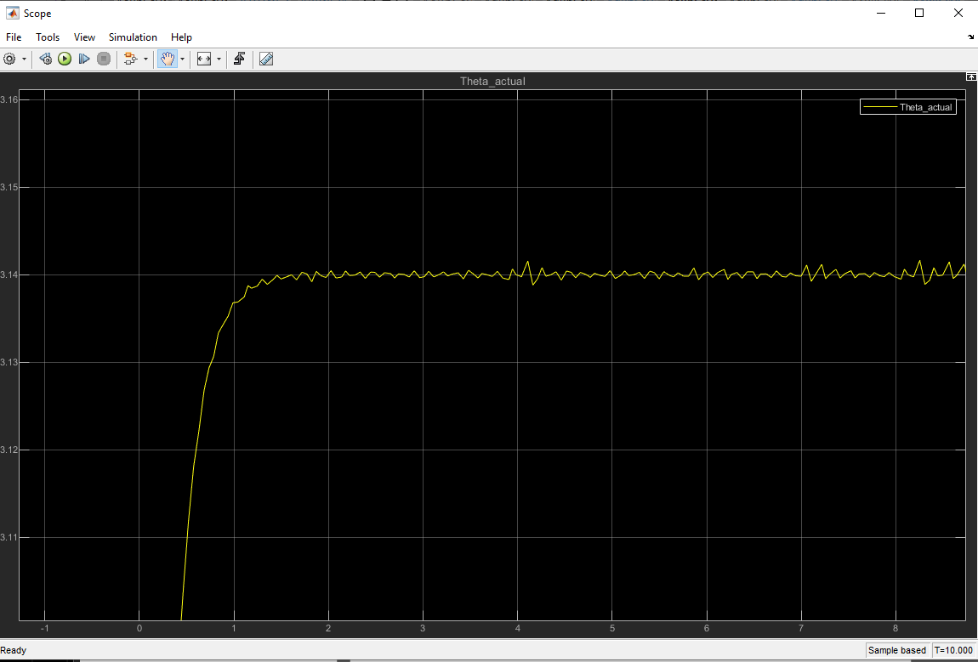

It settles at 3.14

**Conclusive remarks:**

1. **The final output is the voltage value to the servo which in turn control the movement of the servo with takes P and D gain values and adjusta the voltage value such that the pendulum deviates(oscillates) less than 10 deg in full vertical position.**
2. **The entire system is linear control system.**
3. **The initial condition of the system is equilibrium hence we auume it to be zero as the the angle of the pendulum increases and it stablalizes thus achieving balance control .**
4. **The poles of the transfer system are at 0 and -0.13 , both lie on the negative real axis and hence the system is stable .**
5. **In the zommed in graph the system oscillated tomaintain a constant position.**